1THE NATURE OF ART AND CREATIVITY
2
CHAPTER 1 THE NATURE OF ART AND CREATIVITY
THINK AHEAD
- 1.1 Describe art as means of visual expression using different media and forms.
- 1.2 Show human creativity as an inherent trait that inspires the production of art.
- 1.3 Demonstrate the diverse intellectual, cultural, and skills backgrounds of artists.
- 1.4 Distinguish form and meaning in visual analysis.
- 1.5 Define the terms representational, abstract, nonrepresentational, and iconography used to discuss art.
Is it necessary for us to give physical form to things we feel, think, and imagine? Must we gesture, dance, draw, speak, sing, write, and build? To be fully human, it seems we must. In fact, the ability to create is one of the special characteristics of being human. The urge to make and enjoy what we call art has been a driving force throughout human history. Art is not something apart from us. It grows from common—as well as uncom- mon—human insights, feelings, and experiences.
Art does not need to be “understood” to be enjoyed. Like life itself, it can simply be experienced. Yet the more we understand what art can offer, the richer our experience of it will be.
For example, when Janet Echelman’s huge artwork Her Secret Is Patience (fig. 1.1) was hoisted into the air above Phoenix in mid-2009, even most of the doubters became admirers once they experienced this stunning work. Suspended from three leaning poles between 40 and 100 feet above the ground, its colored circles of netting appear both permanent and ever changing, solid yet spacious, defying gravity as they dance and wave slowly in the breeze.
The artist chose the cactus flower shape to sym- bolize the Arizona desert city of Phoenix. She was inspired by the patience of the saguaro cactus, she
Listen to the chapter audio on myartslab.com
said, “a spiny cactus putting down roots in search of water in the desert, saving up every ounce of energy until, one night, in the middle of the cool darkness, it unfurls one succulent bloom.”1 The work also refers to the character of nature itself. Echelman drew her title from the words of American poet and philosopher Ralph Waldo Emerson, who wrote, “Adopt the pace of nature; her secret is patience.”
The citizens who advocated the piece over the extended waiting time between conception and com- pletion were patient as well. Doubters objected to the price tag ($2.4 million), the shape (one said it resem- bled a giant jellyfish), and the artist’s origins (she is not from Arizona). Those misgivings and a few technical issues kept Her Secret Is Patience on the drawing board for a year and a half. But today most Arizonians look on the work with pride: This unique visual delight has become a landmark for the city of Phoenix just as the Eiffel Tower became one for Paris. The Arizona Republic editorialized: “This is just what Phoenix needs: a dis- tinctive feature that helps create a real sense of place.”2
The creation and the reception of Her Secret Is Patience embody an important idea: artistic creation is a two-way street. That is, we form art, and then the art forms us by enriching our lives, teaching us, touching our spirits, commemorating our human past, and inspiring or persuading us (see Chapter 2).

1.1 Janet Echelman. Her Secret Is Patience. 2009. Fiber, steel, and lighting. Height 100 ́ with a top diameter of 100 ́. Civic Space Park, Phoenix, AZ. Courtesy Janet Echelman, Inc. Photograph: Will Novak.
It can also challenge us to think and see in new ways, and help each of us to develop a personal sense of beauty and truth.
While Her Secret Is Patience may not resemble the type of artwork that you are familiar with—it is not a painting, and it is not in a museum—it is art. In this chapter we will explore some definitions of what is meant by “art” and “creativity,” and look at how cre- ativity is expressed through different types of art and through its form and content.
What is Art?
When people speak of the arts, they are usually refer- ring to music, dance, theater, literature, and the visual arts. Each artform is perceived in different ways by our senses, yet each grows from a common need to give expressive substance to feelings, insights, and experi- ences. The arts communicate meanings that go far beyond ordinary verbal exchange, and artists use the entire range of thought, feeling, and observation as the subjects of their art.
The visual arts include drawing, painting, sculp- ture, film, architecture, and design. Some ideas and feelings can best be communicated only through visual forms. American painter Georgia O’Keeffe said: “I found that I could say things with colors and shapes that I couldn’t say in any other way—things I had no words for.”3
A work of art is the visual expression of an idea or experience, formed with skill, through the use of a medium. A medium is a particular material, along with its accompanying technique. (The plural is media.) Artists select media to suit the function of the work, as well as the ideas they wish to present. When a medium is used in such a way that the object or per- formance contributes to our understanding or enjoy- ment of life, we experience the final product as art.
For Her Secret Is Patience, Echelman sought to cre- ate a work that would say something about the Phoenix area, in a way that harmonized with the forces of nature. Thus, she chose flexible netting for the medium because it responds gracefully to the wind. She similarly
THE NATURE OF ART AND CREATIVITY CHAPTER 1 3
4
CHAPTER 1 THE NATURE OF ART AND CREATIVITY
chose the size, scale, shape, and color of the work that would best support and express her message.
Media in use for many centuries include clay, fiber, stone, wood, and paint. By the mid-twentieth century, modern technology had added new media, including video and computers, to the nineteenth-century contri- butions of photography and motion pictures. Art made with a combination of different materials, as many art- ists do today, is referred to as mixed media.
What is Creativity?
The source of all art, science, and technology—in fact, all of civilization—is human imagination, or cre- ative thinking. But what do we mean by this talent we call “creativity”?
Creativity is the ability to bring forth something new that has value. Mere novelty is not enough; the new thing must have some relevance, or unlock some new way of thinking.
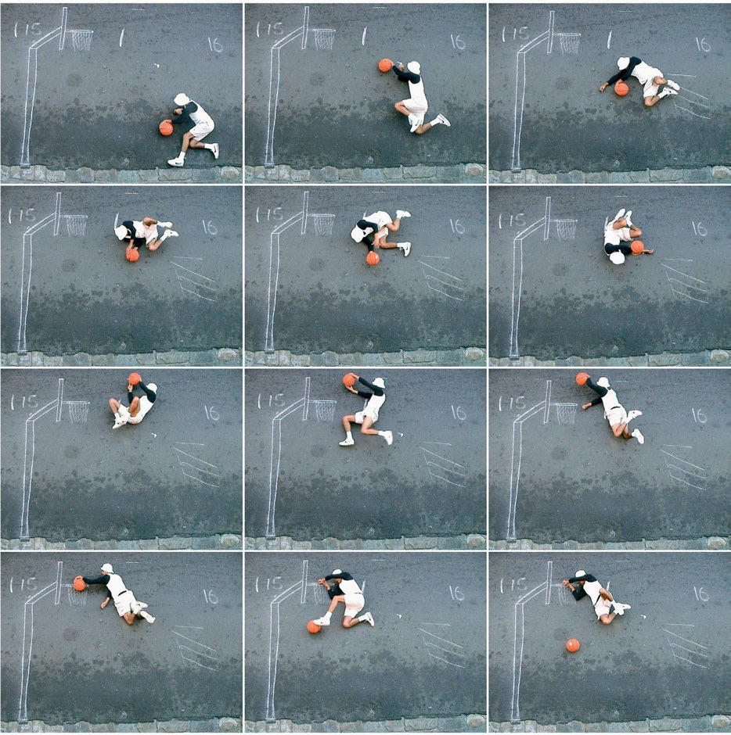
1.2 Robin Rhode.
He Got Game. 2000. Twelve color photographs. Lehmann Maupin, New York and Hong Kong © Robin Rhode.
Creativity also has the potential to influence future thought or action and is vital to most walks of life. In 2010, the IBM corporation interviewed 1,500 chief executive officers (CEOs) from 60 countries, asking them what was the most important leadership skill for the successful businesses of the future. Their answer was not economic knowledge, management skills, integrity, or personal discipline, but creativity.
While studying creative people in several disci- plines, the authors of the 2011 book Innovator’s DNA4 found five traits that seem to define creativity:
- Associating. The ability to make connections across seemingly unrelated fields.
- Questioning. Persistently challenging the status quo, asking why things function as they do now, and how or why they might be changed.
- Observing. Intently watching the world around, without judgment, in search of new insights or ways of operating.
- Networking. Being willing to interact with others, and learn from them, even if their views are radically different or their competencies seem unrelated.
- Experimenting. Exploring new possibilities by try- ing them out, building models, and taking them apart for further improvement.
Creativity can be found in most human endeavors, but here we focus on artistic creativity, which can take many forms. A film director places actors and cameras on a stage in order to emphasize a certain aspect of the script. A Hopi potter decorates a water jar by combin- ing traditional designs in new ways. A graphic designer seated at a computer screen arranges a composition of type, images, and colors in order to help get his or her message across. A carver in Japan fashions wood into a Buddha that will aid in meditation at a monastery. Most of us have at some time arranged images on our walls or composed a picture for a camera. All of these actions involve visual creativity, the use of imagery to communicate beyond what mere words can say.
He Got Game (fig. 1.2) is a good example of visual creativity using simple means. Contemporary South African artist Robin Rhode drew a basketball hoop on the asphalt surface of a street, and then photographed himself lying down in 12 positions as if he were
flipping through the air performing an impossible slam dunk. The artist here imitates the slow-motion and stop-motion photography often seen in sports television to create a piece with transcendent dramatic flair. The work cleverly uses low-tech chalk drawing and a slangy title to celebrate the cheeky boastful- ness of street culture. As it clearly shows, creativity is an attitude; one that is as fundamental to experienc- ing and appreciating a work of art as it is to making one. Insightful seeing is itself a creative act; it requires open receptivity—putting aside habitual modes of thought—and a willingness to stretch the mind.
Twentieth-century American artist Romare Bearden showed a different type of creativity in his depictions of the daily life he witnessed in the rural South and in Harlem, New York City. In Prevalence of Ritual: Tidings (fig. 1.3) he created a photomon- tage using borrowed picture fragments with a few muted colors to portray a mood of melancholy and longing. In the work, a winged figure seems to com- fort an introspective woman who holds a flower, sug- gesting the story of the Christian Annunciation; a train implies departure perhaps from this world or simply to a better life in the North. In this photo- montage, as in many of his others, Bearden was con- cerned with the effectiveness of his communication
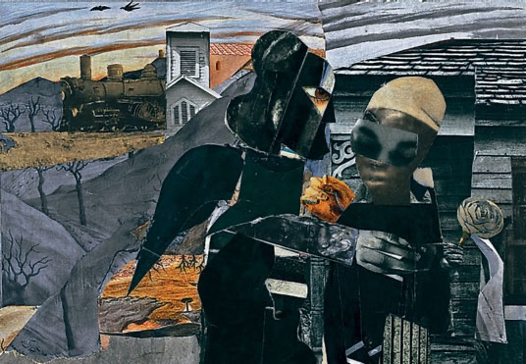
1.3 Romare Bearden.
Prevalence of Ritual: Tidings. 1967.
Photomontage. 36 ̋ × 48 ̋.
© Romare Bearden Foundation/Licensed by VAGA, New York, NY.
Watch a video of Romare Bearden discussing his work on myartslab.com
THE NATURE OF ART AND CREATIVITY CHAPTER 1 5
FORMING ART
Romare Bearden (1911–88): Jazz and Memory
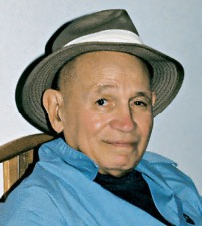
1.4 Romare Bearden Bernard Brown & Associates.
How can the influence of jazz and memory spark creativity and help form visual art? Romare Bearden shows us how. Growing up in Harlem in the 1920s and 1930s,
he witnessed firsthand the outpouring of African-American culture called the Harlem Renaissance. His mother
was a political activist and journalist, his father a city inspector. The musicians, artists, and authors of the Harlem Renaissance were frequent guests in his home.
In his youth, he drew political cartoons for an African- American newspaper. He studied art in New York,
and in Paris after his army service in World War II. During his European study he met several leading African intellectuals who urged
artists to reconnect with their ethnic roots. But Bearden went beyond his heritage and reached for a wider impact. Of his Paris years, he recalled, “The biggest thing
I learned was reaching into your consciousness of black experience and relating it to universals.”5
Being intellectually curious about all sorts of traditions helped enable his quest. He admired the novels of Irish writer James Joyce and the art of the early Italian Renaissance. Novelist Ralph Ellison recounted Bearden’s wide knowledge of the history of art: “I can recall visits to Romie’s 125th Street studio during which he stood
at his easel sketching, and explaining the perspectives of the Dutch and Italian masters.”6 He made paintings inspired by the seventeenth-century poet Andrew Marvell, by the Bible, and by the Iliad of Homer.
Music weighed even more potently in Bearden’s creativity. He knew Duke Ellington, Fats Waller, and singer-actor Paul Robeson. Bearden said, “I’d take a sheet of paper and just make lines while I listened to records, a kind of shorthand to pick up the rhythm and the intervals.”7 He was especially drawn to the piano style of Earl “Fatha” Hines. Bearden listened both to the notes and to the spaces between them, discerning musical structures that influenced his art. He
said of Hines: “His delicate and precise spacing helped me a great deal with pictorial composition.”8
We see this tendency at work in his collage Rocket to the Moon (fig. 1.5), where collage fragments build a scene
of quiet despair and stoic perseverance. The buildings are large blocks that function like verses of a song, with a space between. The figures are more detailed, like embellishing
musical notes. “You put down one color,” the artist said, “and it calls for another. You have
to look at it like a melody.”9 Just as the construction of a song can sound inevitable, so the parts of an artwork should hang together easily.
Of course, the African- American roots of his work are inescapable. “You should always respect what you are in your culture, because if your art’s going to mean anything, that’s where it has to come from,” he said.10 Rocket to
the Moon tells of a certain indifference in urban black neighborhoods to the
fact of the lunar exploration.
Bearden kept a list of key events from his life on the
wall of his studio. He often drew upon memories of his childhood in North Carolina. The idea of homecoming fascinated him. He said, “You can come back to where
you started from with added experience and you hope more understanding. You leave and then return to the homeland of your imagination.”11
Interviewed for a retrospective exhibition at the San Francisco Museum of Modern Art, he explained his goal as an artist: “I have tried to bring
the Afro-American experience into art and give it a universal dimension.”12 Through his creativity, and with the aid
of jazz and memory, he succeeded.
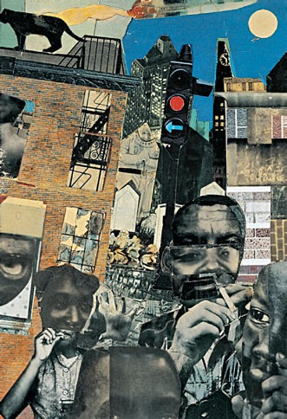
6
CHAPTER 1 THE NATURE OF ART AND CREATIVITY
1.5 Romare Bearden. Rocket to the Moon. 1971.
Collage on board. 13 ̋ × 91⁄4 ̋.
© Romare Bearden Foundation/Licensed by VAGA, New York, NY.
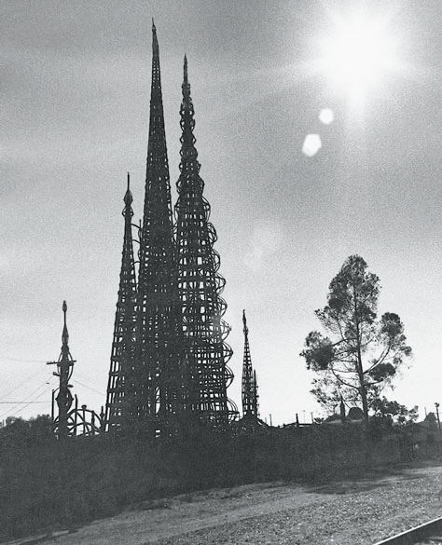
to others, but equally important was his own inner need for creative expression—an aspect of how art forms us (see Chapter 2).
Trained and Untrained Artists
Most of us tend to think of “art” as something pro- duced only by “artists”—uniquely gifted people— and because art is often separated from community life in contemporary society, many people believe they have no artistic talent. Yet we all have the potential to be creative.
In the past, the world’s trained artists generally learned by working as apprentices to accomplished masters. (With a few notable exceptions, women were excluded from such apprenticeships.) Through practi- cal experience, they gained necessary skills and devel- oped knowledge of their society’s art traditions. Today most art training takes place in art schools, or in college or university art departments. Learning in such settings develops sophisticated knowledge of alternative points of view, both contemporary and historical, and often trained artists show a self-conscious awareness of their relationship to art history.
While training, skills, and intelligence are helpful in creativity, they are not always necessary. The urge to create is universal and has little to do with art train- ing. Those with a small amount of or no formal art education—usually described as untrained artists or folk artists—and children can be highly creative. Art by untrained artists, also called naïve or outsider art- ists, is made by people who are largely unaware of art history or the art trends of their time. Unlike folk art, which is made by people working within a tradition, art by outsider artists is personal expression created apart from any conventional practice or style.
One of the best-known (and largest) pieces of out- sider art in the United States is Nuestro Pueblo (Our Town), more commonly known as the Watts Towers (fig. 1.6). Creator Sabatino “Simon” Rodia exem- plifies the artist who visualizes new possibilities for ordinary materials. He worked on his cathedral-like towers for 33 years, making the fantastic structures from cast-off materials such as metal pipes and bed frames held together with steel reinforcing rods, mesh, and mortar. Incredibly, he built the towers without power tools, rivets, welds, or bolts.
1.6 Sabatino “Simon” Rodia. Nuestro Pueblo.
Top: distant view. Bottom: detail of enclosing wall with construction tool impressions. 1921–1954. Mixed media. Height 100 ́. Watts, California. Photographs: Duane Preble.
As the towers rose in his triangular backyard, he methodically covered their surfaces with bits and pieces of broken dishes, tile, melted bottle glass, shells, and other colorful junk from the vacant lots of his neighborhood. Rodia’s towers are testimony to the art- ist’s creativity and perseverance. He said, “I had it in mind to do something big, and I did it.”13
Some creative people are so far outside the art world that their names are unknown to us. In 1982, an art student in Philadelphia found several boxes of
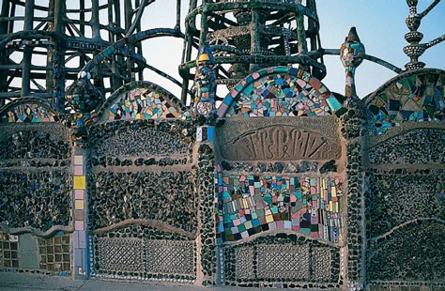
THE NATURE OF ART AND CREATIVITY CHAPTER 1 7
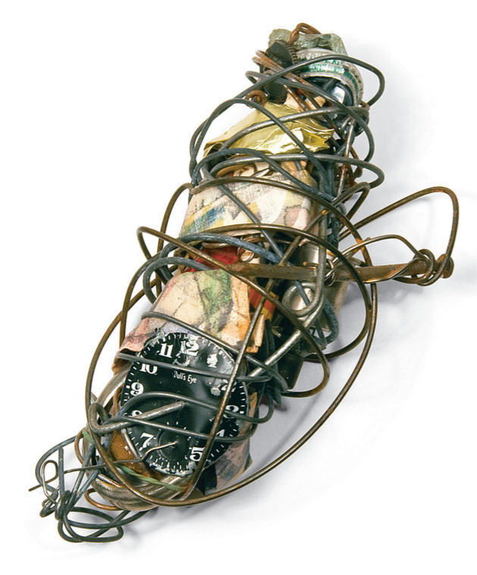
1.7 Philadelphia Wireman. Untitled (Watch Face). c.1970. Watch face, bottle cap, nail, drawing on paper, and wire.
7 ̋ × 31⁄2 ̋ × 21⁄4 ̋. Courtesy Matthew Marks Gallery.
hand-sized sculptures that had been set out among the trash in a run-down neighborhood. Numbering more than a thousand, the sculptures were collections of refuse and other small objects, all wrapped in wire (fig. 1.7). Dubbed the Philadelphia Wireman, the creator of these works is still unknown, as no one has yet claimed authorship after several exhibitions of the works. Because of the force required to bend the wire, the artist is generally thought to have been male. In any case, he created compelling conglomerations of debris that stir memory and imagination.
In contrast to outsider artists, folk artists are part of established traditions of style, theme, and craftsman- ship. Most folk artists have little systematic art train- ing, and their work often shows great enthusiasm or devotion to tradition. Folk art can take many forms, including quilts, embroidered handkerchiefs, deco- rated weather vanes, sculptures, or customized cars.
In Mexico and the American Southwest, retablo painting is a customary way of giving thanks to God when someone escapes from some danger or recovers
from an illness. Such paintings gen- erally depict the scene of salvation along with a narrative of the events. In this example (fig. 1.8), a man falsely accused of a crime escaped execution and created the painting. The inscription credits the “fervent prayers of my dear parents and my aggrieved wife” for saving him from the ultimate punishment. The spelling errors in the inscription combine with the sincere and charming painting style
to yield a highly attractive work. Children use a universal visual lan- guage. All over the world, drawings by children aged two to six show similar
1.8 Retablo. 1915.
Paint on tin. 9 ̋ × 11 ̋.
Fowler Museum at UCLA. Photograph by Don Cole.
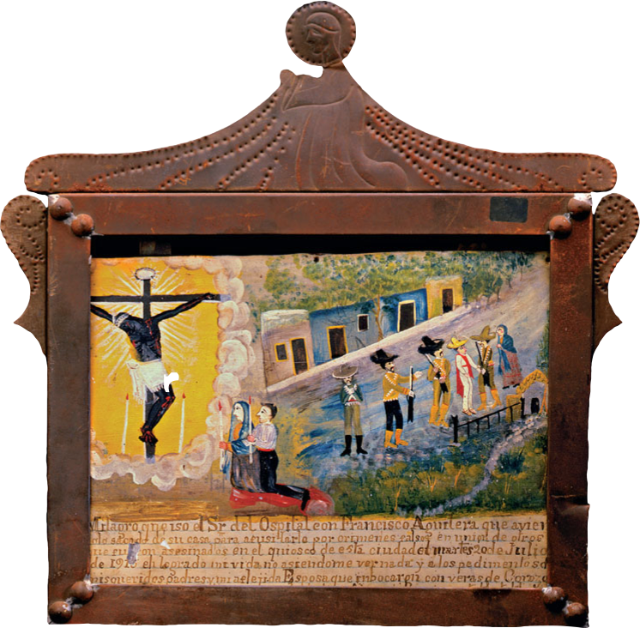
8 CHAPTER 1
THE NATURE OF ART AND CREATIVITY
1.9 Alana, age 3. Grandma.
Representational Art
Representational art depicts the appearance of things. (When human form is the primary subject, it is called figurative art.) It represents—or “presents again”— objects we recognize from the natural, everyday world. Objects that representational art depicts are called subjects.
There are many ways to create representational art. The most “real”-looking paintings are in a style called trompe l’oeil (pronounced “tromp loy”)—French for “fool the eye.” Paintings in this illusionistic style impress us because they look so “real.” In Harnett’s painting A Smoke Backstage (fig. 1.10), the assembled objects are close to life-size, which contributes to the illusion. We almost believe that we could touch the pipe and match.
Belgian painter René Magritte shows a different relationship between art and reality (fig. 1.11). The subject of the painting appears to be a pipe, but writ- ten in French on the painting are the words, “This is not a pipe.” The viewer may wonder, “If this is not a pipe, what is it?” The answer, of course, is that it is a painting! Magritte’s title, The Treachery of Images (La Trahison des Images), suggests the visual game that the artist had in mind.
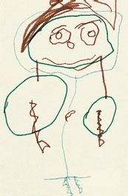
stages of mental growth, from exploring with mark-making, to inventing shapes, to symbolizing things seen and imagined. Until they are about six years old, chil-
dren usually depict the world in symbolic rather than realistic ways. Their images are more mental construc- tions than records of visual observations. The draw- ing Grandma (fig. 1.9) by three-year-old Alana shows enthusiasm and self-assurance in the repeated circles of green and brown. She found a rhythm in the eyes and the head, and she followed it exuberantly out to the sleeves.
Young children often demonstrate an intuitive sense of composition. Unfortunately, much of this intuitive sense of balanced design is lost when they begin to look at the world from a conceptual and self-conscious point of view. Most children who have been given coloring books, workbooks, and predrawn printed single sheets become overly dependent on such impersonal stereotyped props. In this way, chil- dren often lose the urge to invent unique images based on their own experiences. Recent research shows that many children begin to doubt their creativity at about the age of nine or ten years. But creative people, be they artists or CEOs, retain their creativity into adulthood.
Whether trained, outsider, or folk, artists must be independent thinkers and must have the courage to go beyond group mentality. In this way artists can offer fresh insights that extend the experiences of those who see their art.
Art and Reality
Artists may depict what they see in the physical world, they may alter appearances, or they may utilize forms that no one has seen in either the natural or the human- made world. Regardless of their approaches, most art- ists invite viewers to see beyond mere appearances. The terms representational, abstract, and nonrepresenta- tional are used to describe an artwork’s relationship to the physical world.
1.10 William Harnett. A Smoke Backstage. 1877.
Oil on canvas. 7 ̋ × 81⁄2 ̋.
Honolulu Museum of Art, Gift of John Wyatt Gregg Allerton, 1964. (32111).
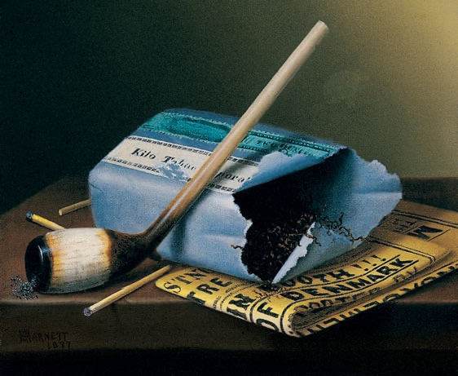
THE NATURE OF ART AND CREATIVITY CHAPTER 1 9
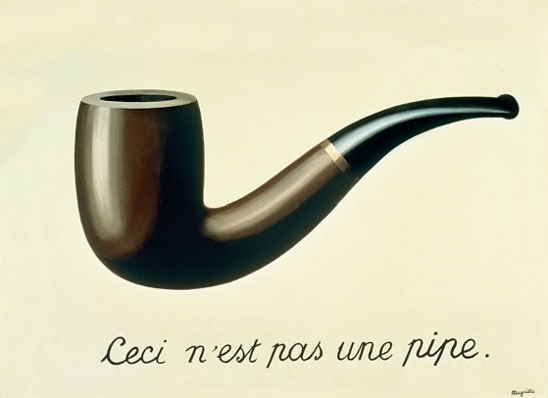
1.11 René Magritte. La Trahison des Images (Ceci N’est Pas une Pipe). 1929.
Oil on canvas. 253⁄8 ̋ × 37 ̋.
Los Angeles County Museum of Art (LACMA). Purchased with funds provided by the Mr. and Mrs. William Preston Harrison Collection (78.7). Digital Image Museum Associates/LACMA/Art Resource NY/ Scala, Florence © 2013 C. Herscovici, London/Artists Rights Society (ARS), New York.
1.12 Ray Beldner. This Is Definitely Not a Pipe. 2000. After René Magritte’s The Treachery of Images (1929).
Sewn US currency. 24 ̋ × 33 ̋. Courtesy of the artist.
Watch a podcast interview with Ray Beldner about his “money pieces” on myartslab.com
California artist Ray Beldner further complicated the relationship between art and reality. He created a reproduction of Magritte’s painting out of sewn dollar bills, and called it This is Definitely Not a Pipe (fig. 1.12). Modern artists are so famous these days,
1.13 Chief’s stool. Late 19th–early 20th century. Wood plant fibre. Height 161⁄2 ̋.
Western Grasslands, Cameroon.
Fowler Museum at UCLA. Photograph by Don Cole.
and their work sells for such high prices, that they may as well be “made of money,” just as this work is. Beldner’s point is that even representational art has a complex relationship to reality; artists almost never merely depict what they see. Rather, they select, arrange, and compose reality to fit their personal vision. The process can take them several steps away from the fact of a pipe on a tabletop.
Abstract Art
The verb “to abstract” means “to take from”; it means to extract the essence of an object or idea. In art, the word “abstract” can mean either (1) works of art that have no reference at all to natural objects, or (2) works that depict
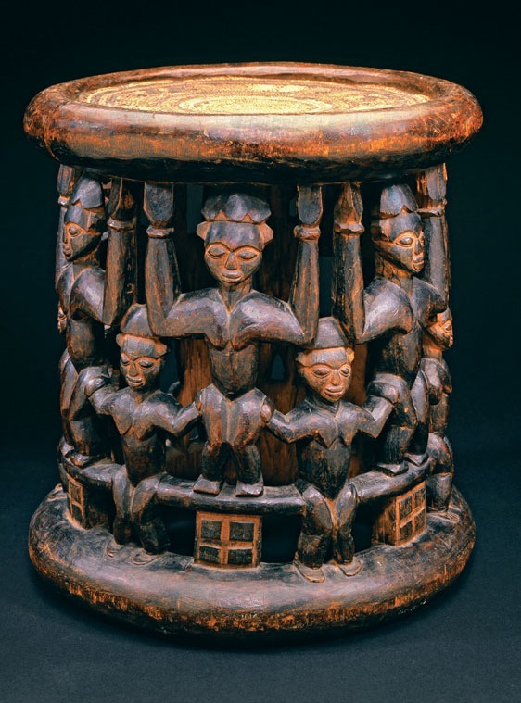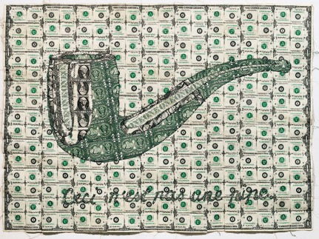
10
CHAPTER 1 THE NATURE OF ART AND CREATIVITY
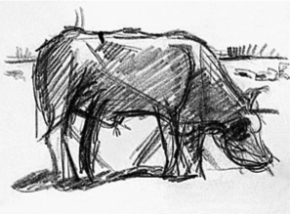
1.14 Theo van Doesburg
(born C. E. M. Küpper). Abstraction of a Cow series.
Museum of Modern Art (MoMA) Purchase 227.1948.1 (top left), 227.1948.6 (top right), 226.1948 (bottom left), and 225.1948 (bottom right). © 2013 Digital image, The Museum of Modern Art, New York/Scala, Florence.
top two images:
Composition (The Cow). c.1917. Pencil on paper.
Each 45⁄8 ̋ × 61⁄4 ̋.
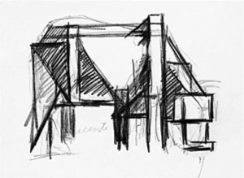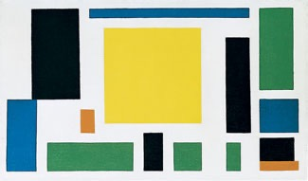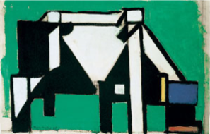
Composition (The Cow). c.1917. Tempera, oil, and charcoal on paper. 155⁄8 ̋ × 223⁄4 ̋.
natural objects in simplified, distorted, or exaggerated ways. Here we use abstract in the second sense.
In abstract art the artist changes the object’s nat- ural appearance in order to emphasize or reveal certain qualities. Just as there are many approaches to represen- tational art, there are many approaches to abstraction. We may be able to recognize the subject matter of an abstract work quite easily, or we may need the help of a clue (such as a title). The interaction between how the subject actually looks and how an artist presents it is part of the pleasure and challenge of abstract art.
Abstraction in one form or another is common in the art of many cultures. The chief ’s stool (fig. 1.13) from Cameroon shows repeated abstractions of the human form. We still recognize, of course, that the principal subject of the sculpture is people. They sym- bolize the community of the Cameroon grasslands that supports the chief who sits on this stool. This piece was regarded as the chief ’s “seat of power.” No one else was allowed to use it, and when he died, according to custom, the stool was buried or thrown away.
Early modern artists in Europe also embraced abstraction. We see stages of abstraction in Theo van Doesburg’s series of drawings and paintings,
Composition VIII (The Cow). c.1918. Oil on canvas. 141⁄4 ̋ × 25 ̋.
Abstraction of a Cow (fig. 1.14). The artist appar- ently wanted to see how far he could abstract the cow through simplification and still have his image sym- bolize the essence of the animal. Van Doesburg used the subject as a point of departure for a composition made up of colored rectangles. If we viewed only the final painting and none of the earlier ones, we would probably see it as a nonrepresentational painting.
Nonrepresentational Art
A great deal of the world’s art was not meant to be representational at all. Amish quilts, many Navajo textiles, and most Islamic wood carvings consist pri- marily of flat patterns that give pleasure through mere variety of line, shape, and color. Nonrepresentational art (sometimes called nonobjective or nonfigurative art) presents visual forms with no specific references to anything outside themselves. Just as we can respond to the pure sound forms of music, so can we respond to the pure visual forms of nonrepresentational art.
The following two contrasting works show that in nonrepresentational art, an extremely wide variety of forms, compositions, moods, and messages is possible. In Alma Woodsey Thomas’s Gray Night Phenomenon
THE NATURE OF ART AND CREATIVITY CHAPTER 1 11
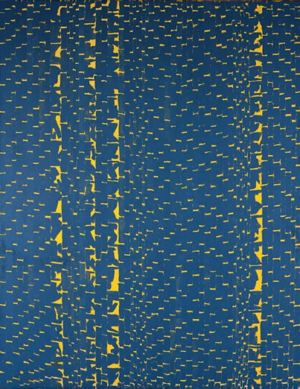
1.15 Alma Woodsey Thomas. Gray Night Phenomenon.
1972. Acrylic on canvas. 687⁄8 ̋ × 531⁄8 ̋.
Smithsonian American Art Museum, Washington, D.C. Gift of Vincent Melzac. © 2013 Photograph Smithsonian American Art Museum/Art Resource/Scala, Florence.
(fig. 1.15) only two colors and brushstrokes that are more or less regular are used. She created a pattern across the picture plane that is neither gray nor night- like. The subject of this work is not from the visible world; rather, it depicts a mood that might strike the artist in the middle of a gray night.
In New Zealand, Maori women working in pairs weave strips of dyed flax into geometric patterns called tukutuku panels (fig. 1.16). These patterns are tradi- tional in Maori societies and they have such names as “sand flounder,” “human ribs,” and “albatross tears.” The panels are woven in specific sizes to fit between the wooden uprights of meeting houses where reli- gious ceremonies are held. A given meeting house may contain tukutuku panels of many different designs, giving the room a rich and varied visual texture.
While nonrepresentational art may at first seem more difficult to grasp than representational or abstract art, it can offer fresh ways of seeing. Absence of sub- ject matter actually clarifies the way all visual forms
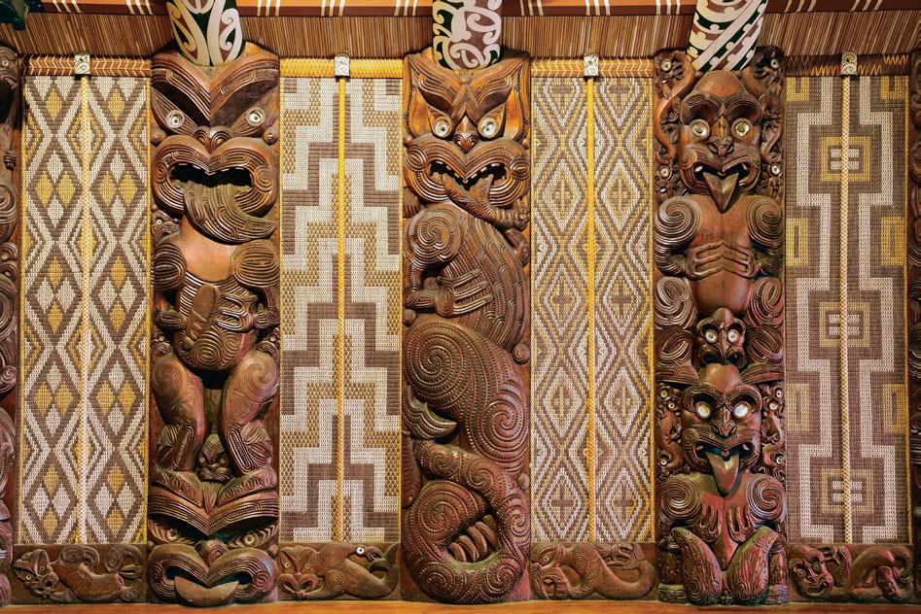
12
CHAPTER 1 THE NATURE OF ART AND CREATIVITY
1.16 Maori peoples, New Zealand. Tukutuku panels. 1930s. Dyed, plaited flax strips over wood laths. Dimensions variable. Te Whare Runanga, Maori Meeting House, New Zealand.
Photograph: David Wall/Alamy.
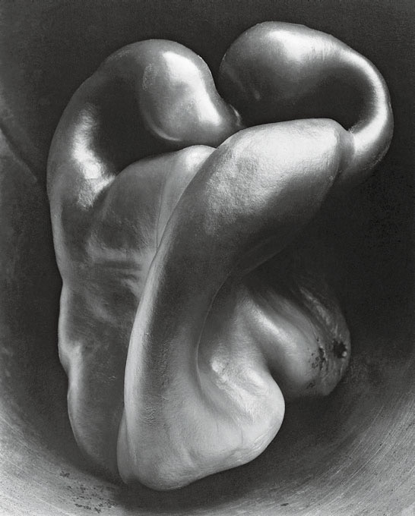
affect us. Once we learn how to “read” the language of vision, we can respond to art and the world with greater understanding and enjoyment.
Looking and Seeing
Whether a work of art is representational, abstract, or nonrepresentational, we access it primarily through our eyes; thus we need to consider how we use them.
The verbs “look” and “see” indicate varying degrees of visual awareness. Looking is habitual and implies taking in what is before us in a generally mechanical or goal-oriented way. If we care only about function, we simply need to look quickly at a doorknob in order to grasp and turn it. But when we get excited about the shape and finish of a doorknob, or the bright quality of a winter day, or we empathize with the creator of an artwork, we go beyond simple, functional looking to a higher level of perception called “seeing.”
Seeing is a more open, receptive, and focused ver- sion of looking. In seeing, we look with our memories, imaginations, and feelings attached. We take in some- thing with our eyes, and then we remember similar experiences, or we imagine other possible outcomes, or we allow ourselves to feel something. We are doing more than looking.
The twentieth-century French artist Henri Matisse wrote about how to see intently:
To see is itself a creative operation, requiring an effort. Everything that we see in our daily life is more or less distorted by acquired habits, and this is perhaps more evident in an age like ours when cinema, posters, and magazines present us every day with a flood of readymade images which are to the eye what prejudices are to the mind. The effort needed to see things without distortion takes something very like courage.14
But, since words and visual images are two different “languages,” talking about visual arts with words is always an act of translation one step removed from actually experiencing art. In fact, our eyes have their own connections to our minds and emotions. By culti- vating these connections, we can take better advantage of what art has to offer.
1.17 Edward Weston. Pepper #30. 1930. Photograph. Photograph by Edward Weston. Collection Center for Creative Photography.
© 1981 Arizona Board of Regents.
Ordinary things become extraordinary when we see them deeply. Is Edward Weston’s photograph of a pepper (fig. 1.17) meaningful to us because we like peppers so much? Probably not. To help us truly see, Weston created a memorable image on a flat surface with the help of a common pepper. A time expo- sure of over two hours gave Pepper #30 a quality of glowing light—a living presence that resembles an embrace. Through his sensitivity to form, Weston revealed how this pepper appeared to him. Notes from his Daybook communicate his enthusiasm about this photograph:
August 8, 1930
I could wait no longer to print them—my new peppers, so I put aside several orders, and yesterday afternoon had an exciting time with seven new negatives.
THE NATURE OF ART AND CREATIVITY CHAPTER 1 13
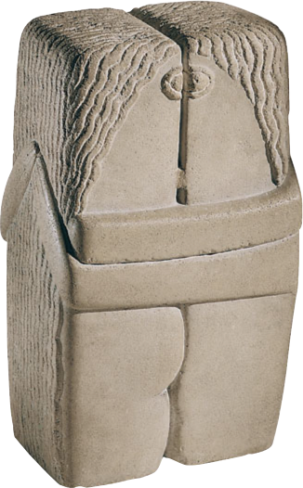
First I printed my favorite, the one
made last Saturday, August 2, just as the
light was failing—quickly made, but with a week’s previous effort back of my immediate, unhesitating decision. A week?—Yes, on this certain pepper,—but twenty-eight years of effort, starting with a youth on a farm in Michigan, armed with a No. 2 Bull’s Eye [Kodak] 31⁄2 × 31⁄2, have gone into the making of this pepper, which I consider a peak of achievement.
It is a classic, completely satisfying—a pepper—but more than a pepper: abstract, in that it is completely outside subject matter . . . this new pepper takes one beyond the world we know in the conscious mind.15
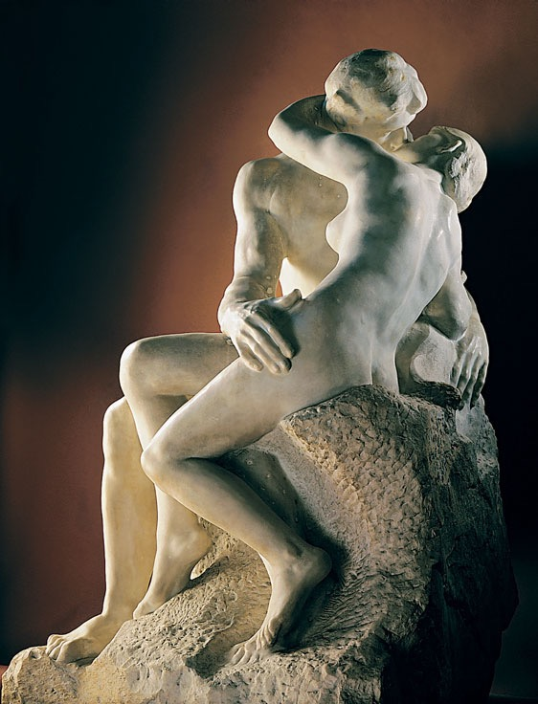
14
CHAPTER 1 THE NATURE OF ART AND CREATIVITY
1.18 Auguste Rodin. The Kiss. 1886. Marble. 5 ́111⁄4 ̋.
Musée Rodin, Paris. RMN-Grand Palais/Agence Bulloz.
1.19 Constantin Brancusi. The Kiss. 1916. Limestone. 23 ̋ × 13 ̋ × 10 ̋.
Photo The Philadelphia Museum of Art/Art Resource/Scala, Florence. © 2013 Artists Rights Society (ARS), New York/ ADAGP, Paris.
Watch a podcast interview about The Kiss on myartslab.com
Weston’s photograph of a seemingly common object is a good example of the creative process at work. The artist was uniquely aware of something in his surround- ings. He worked for a long time (perhaps 28 years!) to achieve the image he wanted. The photograph that resulted not only represents the object but also com- municates a sense of wonder about the natural world.
Finally, seeing is a personal process. No two peo- ple will see the same thing in the same way, because each of us brings our own mental equipment to bear. Confronted with the same visual information, differ- ent people will come to different conclusions about its meaning, worth, or importance (see Chapter 5).
Form and Content
In Weston’s Pepper #30 the texture, light and shadow, and shape of the pepper is the form that we see, and the content is the meaning (or meanings) the work com- municates—for example, a sense of wonder about the natural world. Form thus refers to the total effect of
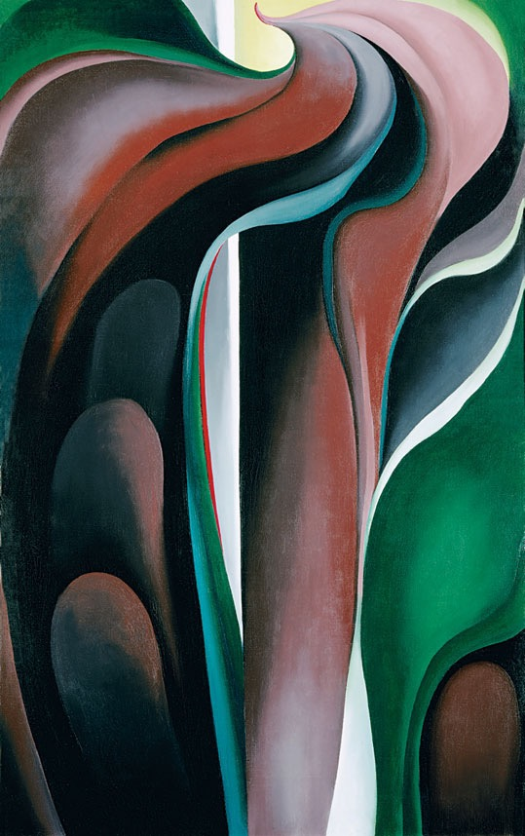
the combined visual qualities within a work, including such components as materials, color, shape, line, and design. Content refers to the message or meaning of the work of art—what the artist expresses or commu- nicates to the viewer. Content determines form, and form expresses content; thus the two are inseparable.
One way to better understand the relationship is to compare works that have the same subject but differ greatly in form and content. The Kiss (fig. 1.18) by Auguste Rodin and The Kiss (fig. 1.19) by Constantin Brancusi show how two sculptors interpret an embrace. In Rodin’s work, the life-size human figures represent Western ideals of the masculine and the fem- inine. Rodin captures the sensual delight of that highly charged moment when lovers embrace. Our emotions are engaged as we overlook the hardness of the marble from which he carved it. The natural softness of flesh is heightened by the rough texture of the unfinished marble supporting the figures.
In contrast to Rodin’s sensuous approach, Brancusi used the solid quality of a block of stone to express lasting love. Through minimal cutting of the block, Brancusi symbolized—rather than illustrated— the concept of two becoming one. He chose geometric abstraction rather than representational naturalism to express love. We might say that Rodin’s work expresses the feelings of love while Brancusi’s expresses the idea of love.
Seeing and Responding to Form
Obviously, artists expend effort to produce a work of art; less obvious is the fact that responding to a work of art also requires effort. The artist is the source or sender of any work put on view; the work itself is the medium carrying the message. We viewers must receive and experience the work to make the commu- nication complete. In this way, we participate in the creative process.
Learning to respond to form is part of learning to live in the world. We guide our actions by “read- ing” forms of people, things, and events that make up our environment. Even as infants, we have an amazing ability to remember visual forms such as faces, and all through life we interpret events based on our previous experiences with these forms. Every form can evoke some kind of response from each of us.
1.20 Georgia O’Keeffe. Jack-in-the-Pulpit No. V. 1930.
Oil on canvas. 48 ̋ × 30 ̋.
Alfred Stieglitz Collection, Bequest of Georgia O’Keeffe, National Gallery of Art, Washington, D.C. 1987.58.4. Photograph: Malcolm Varon © 2013 Georgia O’Keeffe Museum/Artists Rights Society (ARS), New York.
Subject matter can interfere with our percep- tion of form. One way to learn to see form without subject is to look at pictures upside down. Inverting recognizable images frees the mind from the process of identifying and naming things. Familiar objects become unfamiliar.
When confronted with something unfamiliar, we often see it freshly only because we have no idea what we are looking at. For example, when we see the twisting, curving green and rust-red shapes in Georgia O’Keeffe’s painting (fig. 1.20), we may not at first realize that the work depicts a jack-in-the-pulpit
THE NATURE OF ART AND CREATIVITY CHAPTER 1 15
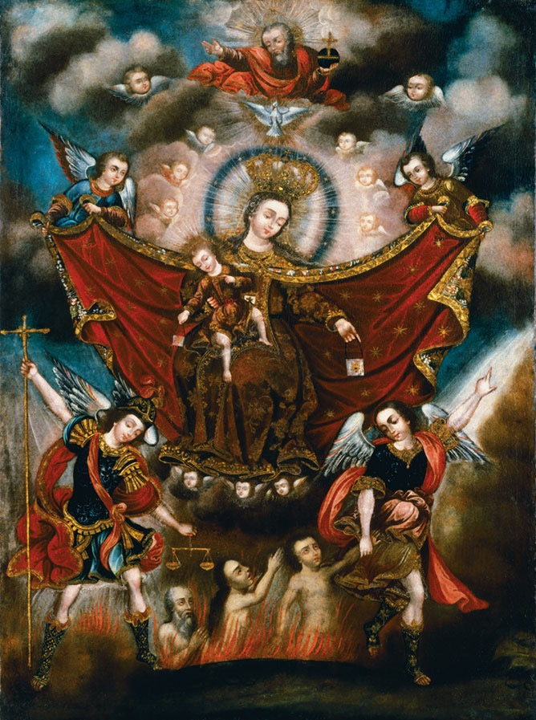
16
CHAPTER 1 THE NATURE OF ART AND CREATIVITY
1.21 Circle of Diego Quispe Tito.
The Virgin of Carmel Saving Souls in Purgatory.
Late 17th century. Oil on canvas. 41 ̋ × 29 ̋. Brooklyn Museum of Art, New York/The Bridgeman Art Library.
flower. The artist greatly enlarged it to 4 feet in height, and she focused closely on the flower, omitting nearly all else. We may wonder for a moment if we are look- ing at abstract or representational art.
O’Keeffe hoped that her way of seeing would cause us to sense the natural rhythms present in a flower. She said of this painting:
Everyone has many associations with a flower—the idea of flowers. Still—in a
way—nobody sees a flower— really—it is so small—we haven’t the time—and to
see takes time, like to have a friend takes time. If I could paint the flower exactly as I see it, no one would see what I see because I would paint it small like the flower is small. So I said to myself—I’ll paint what I see—what
the flower is to me but I’ll paint it big and they will be surprised into taking time to look at it.16
Iconography
As we have noted, form conveys content even when no nameable subject matter is represented. But when subject matter is pres- ent, meaning is often based on traditional interpretations.
Iconography refers to the subjects, symbols, and motifs used in an image to convey its meaning (from the Greek eikon, meaning image or picture). Not all works of art contain ico- nography. In those that do, it is often the symbolism (rather than the obvious subject mat-
ter) that carries the deepest levels of meaning. If we are seeing a painting of a mother and child, for example, its iconography will tell us whether it is Mary and the baby Jesus.
An artist’s use of iconography can reveal a wealth of cultural information. For example, the Peruvian painting The Virgin of Carmel Saving Souls in Purgatory (fig. 1.21) contains many iconographic details that enrich its meaning. Some of these are obvious to those familiar with Christian iconogra- phy: The two winged figures standing in the fore- ground are angels; at the top is God the Father holding the orb of the world; below him is a dove that represents the Holy Spirit; Mary wears a crown
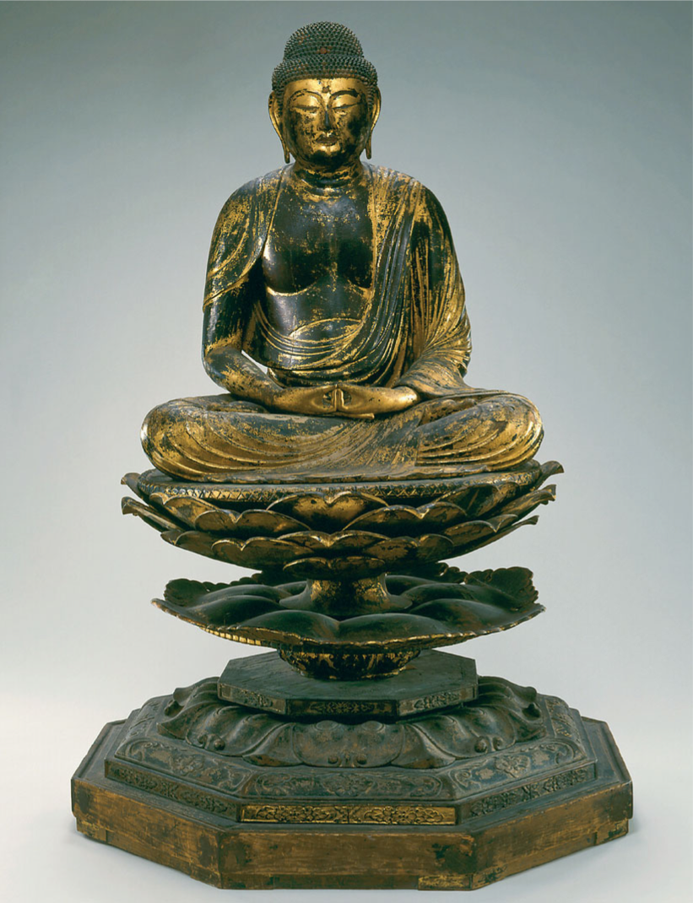
1.22 Amida Buddha. Japan. 12th century.
Wood with traces of lacquer, pigment, and gilding. Height 521⁄2 ̋.
The Avery Brundage Collection, B60S10+ © Asian Art Museum, San Francisco. Used by permission.
to show that she is the Queen of Heaven. People emerge from a flaming pit that is purgatory, led by an angel. In the left corner, another angel holds a cross that symbolizes the sacrifice of Christ; he also holds a balance, symbolizing the weighing of souls that takes place in purgatory. The meaning of these details is established by convention and long use.
Other details might be less familiar but equally meaningful: The Virgin of Carmel refers to an appear- ance of Mary that took place in the thirteenth century; at that time she promised that anyone who wore a spe- cial garment called a scapular would not suffer the fires of hell. Both Mary and the child Jesus carry purselike objects that represent the scapulars that people wore
THE NATURE OF ART AND CREATIVITY CHAPTER 1 17
or carried for protection. In this painting, Mary makes a special effort to save the souls from purgatory who may not have owned the protecting scapular. Thus the work was a sign of hope.
Asian traditions also use a rich iconographic lan- guage, which makes the Amida Buddha (fig. 1.22) easily distinguishable from a portrait of any other seated person. He has a topknot that symbolizes his enlightenment. The long earlobes show that he was
a wealthy prince who wore heavy earrings before he sought religious truth. His garment is simple, as after enlightenment he lived by begging. His hands are folded in the traditional position of meditation. His lotus-flower throne symbolizes the fact that enlight- enment can come in the midst of life, just as a lotus flower may bloom on the surface of a stagnant pond. The degrees of abstraction in the hands, chest, and face point to a twelfth-century date for this work, but
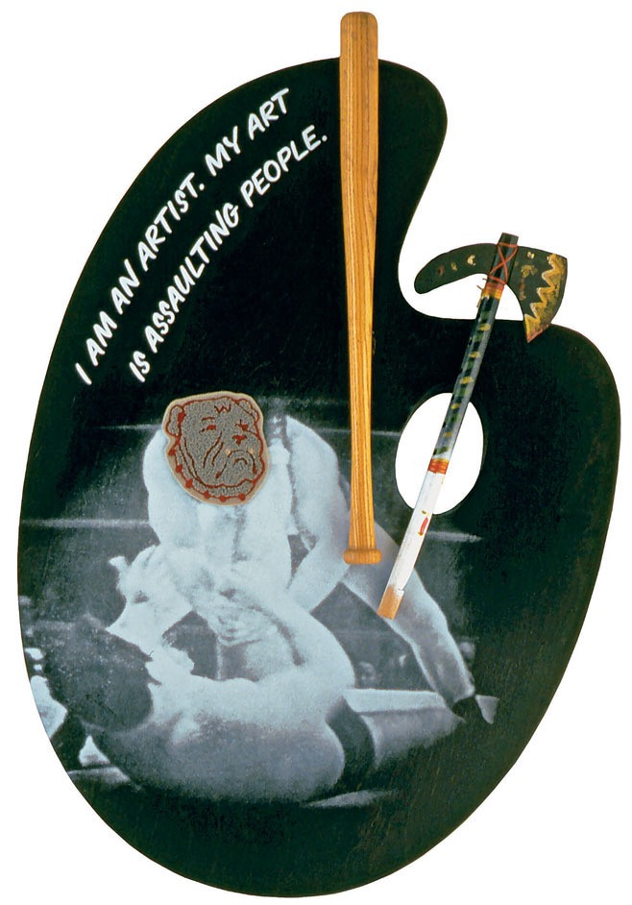
1.23 Alexis Smith. Black ’n’ Blue (for Howie Long). 1997.
Mixed media collage. 30 ̋ × 22 ̋ × 4 ̋.
Photo by Douglas Parker. Courtesy of the artist and Margo Leavin Gallery, Los Angeles.
18 CHAPTER 1 THE NATURE OF ART AND CREATIVITY
the iconographic details that mark him as the Buddha had already been in use for over a thousand years.
In our time, artists often quote and use the ico- nography of popular culture, sometimes in humor- ous ways. Alexis Smith combined references to the art world with the violence of professional sport in her work Black ’n’ Blue (for Howie Long) (fig. 1.23). The sarcastic, inscribed sentence on this work is a quote from Howie Long, who for most of the 1980s was among the most famous (and fiercest) players in the National Football League. A defensive lineman, he set several records for tackles on the opposing quar- terback, for which he was elected to the Pro Football Hall of Fame. After his athletic career he appeared in
THINK BACK
- What is art?
- What are the key traits that define creativity?
- What are some ways that art relates to reality?
- What is the difference between looking and seeing?
movies and worked as a sports analyst on television, cementing his celebrity status.
Smith borrowed his most famous statement and inscribed it on an artist’s palette, along with a photo of wrestlers and some tools that could become weap- ons. She created an “artist’s palette” for an athlete who made his name through jarring physical contact.
As we have seen from the works illustrated in this chapter alone, art is produced in a range of media and for different reasons. Artists, whether trained or untrained, may use their creativity to bring forth some- thing new of value that can enrich and inform our lives.
Study and review on myartslab.com
TRY THIS
Think about the boundaries of art. In response
to Magritte’s painting The Treachery of Images
(fig. 1.11), an artist in a 2011 exhibition hung an actual drainpipe in a frame above his handwritten inscription, “This is a pipe.” Consider whether this creation amounts to a work of art according to the definition given in this chapter.
K E Y T E R M S
abstract art – art that depicts natural objects in simplified, distorted, or exaggerated ways
content – the meaning or message communicated by a work of art, including its emotional, intellectual, symbolic, thematic, and narrative connotations
form – the total effect of the combined visual qualities within a work, including such components as materials, color, shape, line, and design
iconography – the symbolic meanings of subjects and signs used to convey ideas important to particular cultures or religions
medium (plural media) – a particular material along with its accompanying technique
nonrepresentational art – art without reference to anything outside itself
representational art – art that recognizably represents or depicts a particular subject

